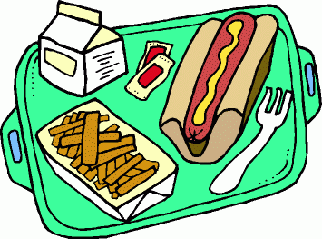
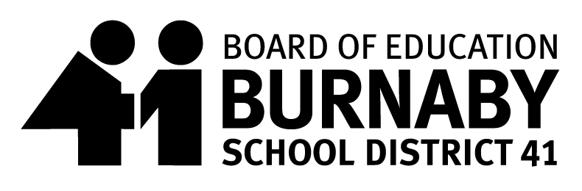
SCHOOL MEAL PROGRAM
Hot Lunch Menu Date: May 5th – May 30th 2025
Thank you for supporting the School Meal Program

Monday | Tuesday | Wednesday | Thursday | Friday
05  Topsy Turvy Pasta  Veggie Topsy Turvy Pasta | 06  Beef Meatball Sub  Veggie Meatball Sub | 07  Butter Chicken with Rice  Butter Chickpeas with Rice | 08  Pancakes  Yogurt | 09  PIZZA
12  Chicken Nuggets  Hashbrown Triangles  Veggie Chick’N’ Nuggets  Hashbrown Triangles | 13  French Toast  Yogurt | 14  DIY Beef Taco Mix  Tortilla Chips  Veggie Ground & Cheese  Tortilla Chips | 15  Pizza Plank | 16  Macaroni & Cheese
19  Victoria Day | 20  Beef Meatball Tater Tot Poutine  Veggie Meatball  Tater Tot Poutine | 21  Honey Garlic Chicken Chow Mein  Honey Garlic Tofu  Chow Mein Noodles | 22  Fish Burger with Cheese  Veggie Burger with Cheese | 23  Beef Lasagna  Vegetarian Lasagna
26  Pro-D  Day | 27  Chicken Burger  Veggie Burger | 28  Spaghetti & Meatballs  Spaghetti & Veggie meatballs | 29  Turkey Hot Dog  Vegetarian Hot Dog | 30  SUBWAY

All Meals include Fruit or Veggie and a small milk

